Figures
Fig. 1Cenotes studied in the Yucatan Peninsula. Cenote Santa María, west from Cancún, Cenotes Tres Reyes, Norte and Limite inside Sian Ka’an Biosphere reserve
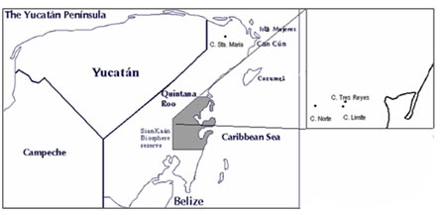

Fig. 2 Fish community structure across the sampling period. a. Fish abundance and b. fish richness. TR = Tres Reyes, SM = Santa María, CL = Cenote Limite and CN = Cenote Norte

a)
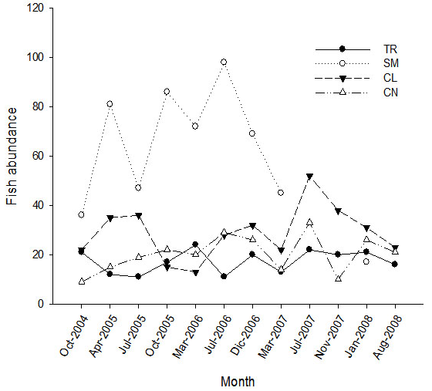

b)
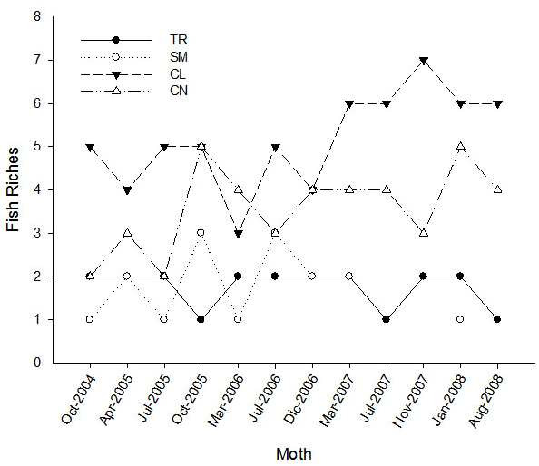

Fig. 3 Rarefaction curves to evaluate species richness for Fish.
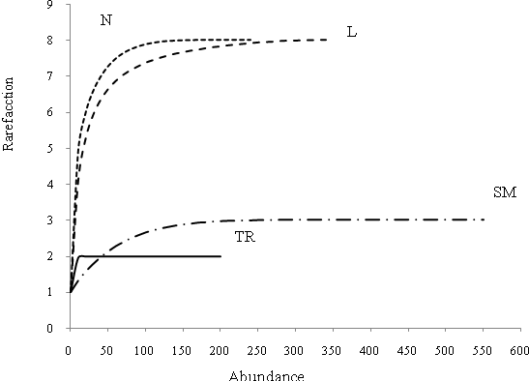
Fig. 4 PCA of the abiotic variables for all of the cenotes in 2004 and 2008. TR = Tres Reyes, SM = Santa María, CL = Límite and CN = Norte

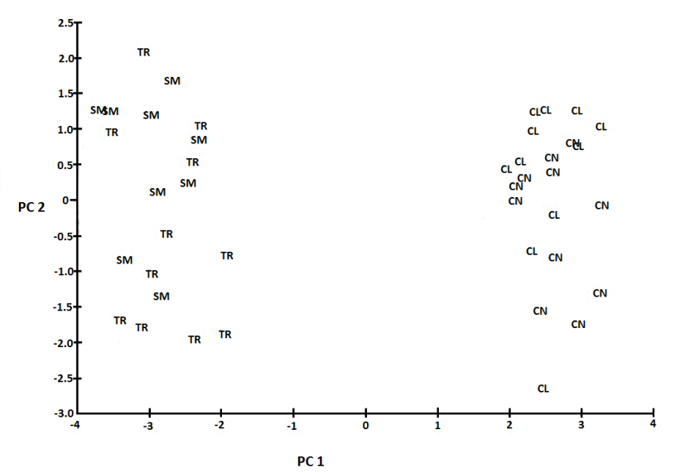

Fig. 5 Non-metric multidimensional scaling ordinations of the fourth square root fish community data in TR = Tres Reyes, SM = Santa Maria, CL = Límite and CN = Norte from 2004 to 2008

