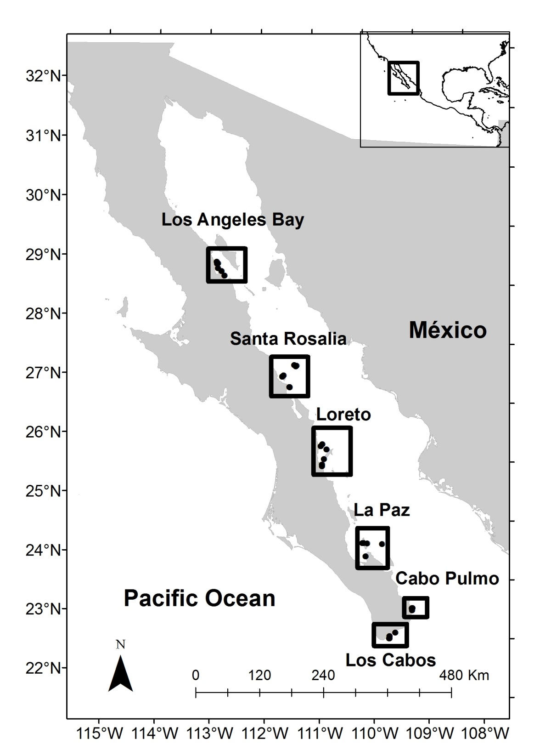

Figure 1. Location of sampling sites.

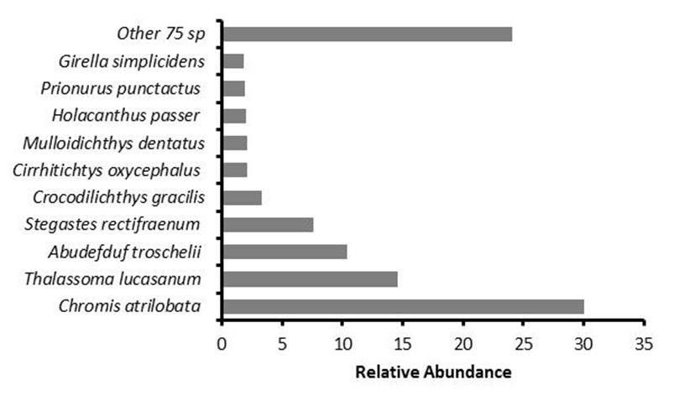

Figure 2. Relative abundance of reef fish species considering the five visited areas of the Gulf of California (N= 31,144 fishes).

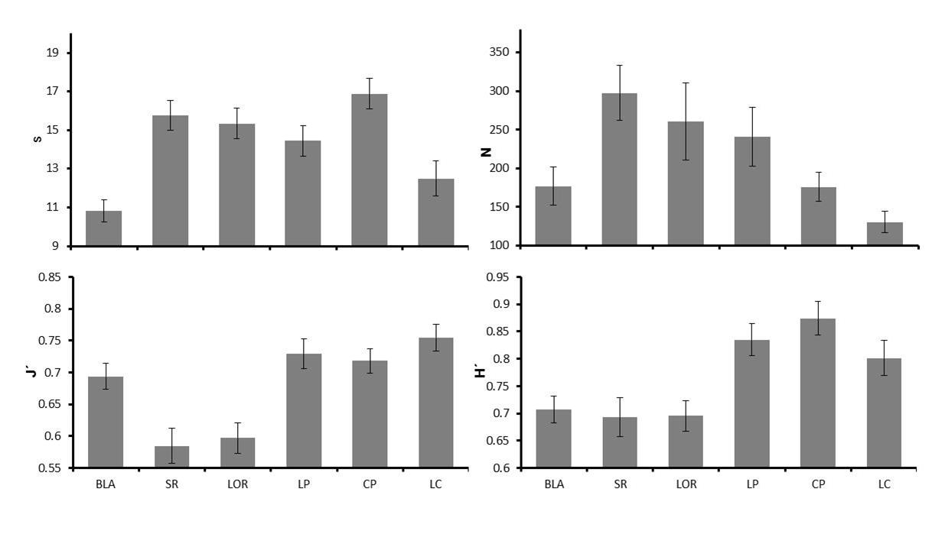

Figure 3. Average and standard error values of species richness (S), abundance (N), Shannon-Wiener diversity (H´) and Pielou´s evenness (J´), by region. Key: BLA: Bahía de los Ángeles; SR: Santa Rosalía; LOR: Loreto; LP: La Paz; CP: Cabo Pulmo; LC: Los Cabos.

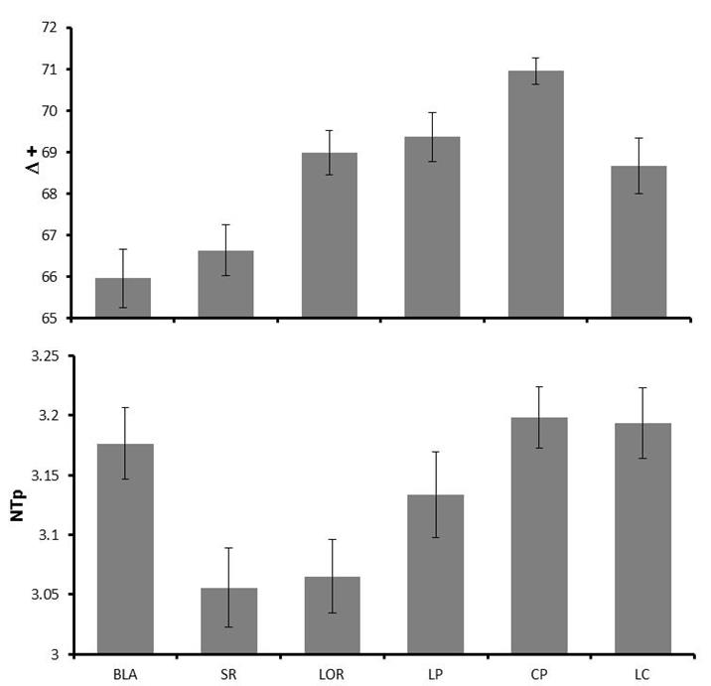

Figure 4. Average and standard error values of taxonomic distinctness (Δ+) and trophic level (NTp) by region. Key: BLA: Bahía de los Ángeles; SR: Santa Rosalía; LOR: Loreto; LP: La Paz; CP: Cabo Pulmo; LC: Los Cabos.



F

E

D

C

B

A

Figure 5. Similarity dendrogram Key: A and B) Anomalous censuses, C) Bahía de los Ángeles, D and F) Santa Rosalía, Loreto and La Paz; E) Cabo Pulmo and Los Cabos.

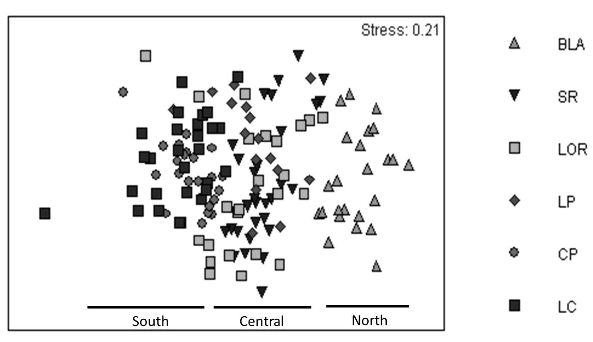

Figure 6. Non-metric dimensional scaling of reef fish assemblages in the Gulf of California. Key: BLA: Bahía de los Ángeles; SR: Santa Rosalía; LOR: Loreto; LP: La Paz; CP: Cabo Pulmo; LC: Los Cabos.

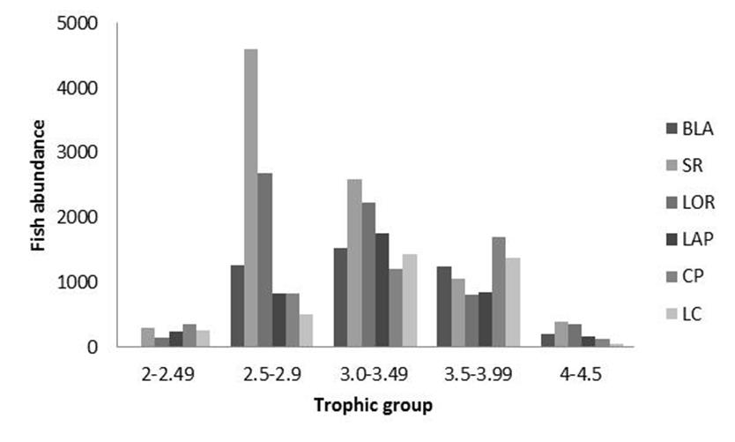

Figure 7 Abundance per trophic group in the Gulf of California. Key: BLA: Bahía de los Ángeles; SR: Santa Rosalía; LOR: Loreto; LP: La Paz; CP: Cabo Pulmo; LC: Los Cabos.