Genetic diversity of Calycolpus moritzianus (Myrtaceae) in the north-eastern Andes of Colombia

Figures

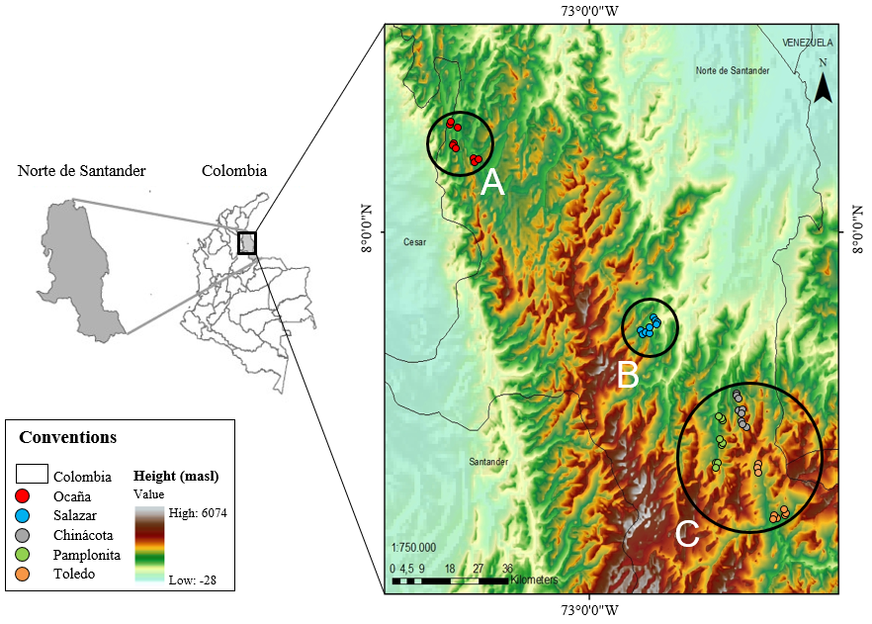

Figure 1. Distribution of the C. moritzianus individuals recorded in Norte de Santander (Colombia, South America). Top of the map, individuals from Ocaña (Group A), the middle Salazar region (Group B) and in the lower part the municipalities of Chinácota, Pamplonita, and Toledo (Group C).

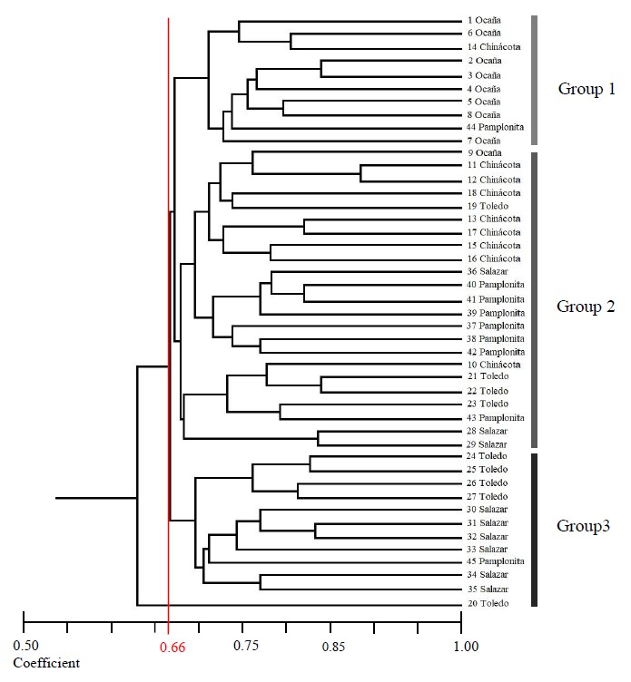

Figure 2. Dendrogram of 45 individuals of Calycolpus moritzianus, based on the coefficient of similarity of Dice (Nei, 1978) and calculated with the combined data of the five RAMs primers.

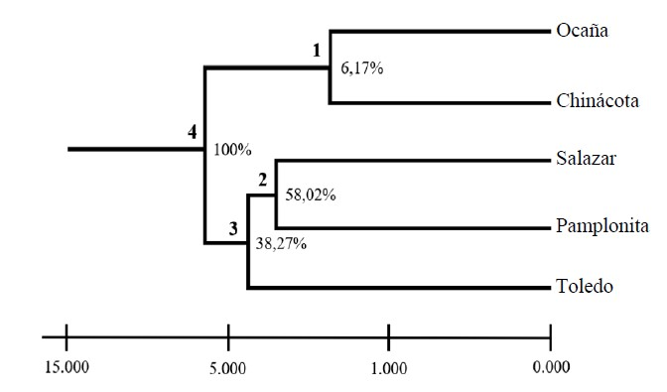

Figure 3. UPGMA from Nei distance (1978) for the five populations analyzed and the respective percentages of loci that support each node.
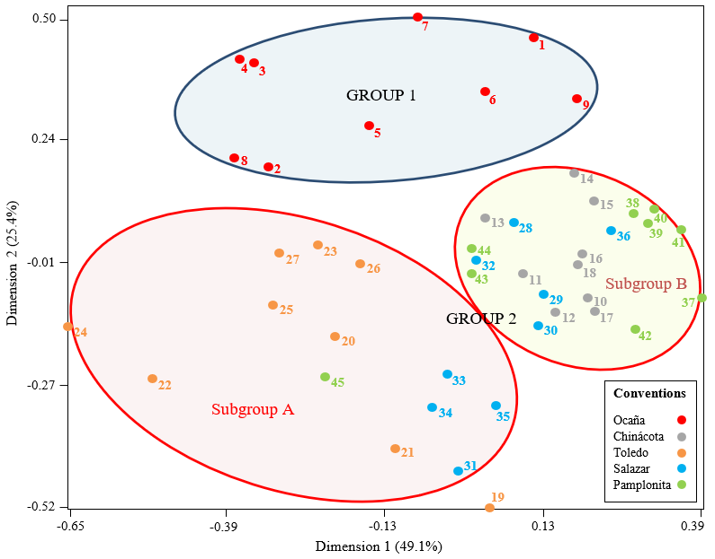

Figure 4. Spatial representation of the 45 individuals of C. moritzianus found by multiple correspondence analysis (MCA).

