Figure 1. Location of the study site, a water reservoir in Severínia, São Paulo, Brazil.

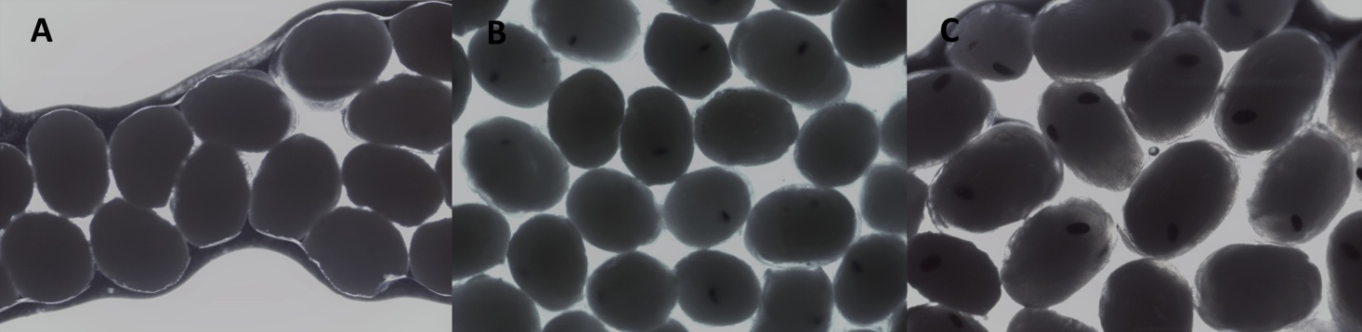

Figure 2. Macrobrachium amazonicum (Heller 1862). Embryonic developmental stages: [A] Early, [B] Intermediate and [C] Late.

Figure 3. Monthly variation of rainfall and water temperature, from May 2017 to April 2018, in Severínia, São Paulo, Brazil.

Figure 4. Macrobrachium amazonicum (Heller, 1862). Relative frequency of ovigerous females (OF) and non-ovigerous females (F), from May 2017 to April 2018, in the water reservoir of Severínia, São Paulo, Brazil. The numbers above the bars indicate the absolute number of OF + F per month.

Figure 5. Macrobrachium amazonicum (Heller, 1862). Relationship between female fecundity and carapace length (CL), by [A] embryonic developmental stages and [B] season.

