Figure 1. Dorsal and lateral views of L. altamirae (USNM 93692) showing black lines on nape, lack of black ear tips and other characteristics of L. callotis and white-sided jackrabbits.

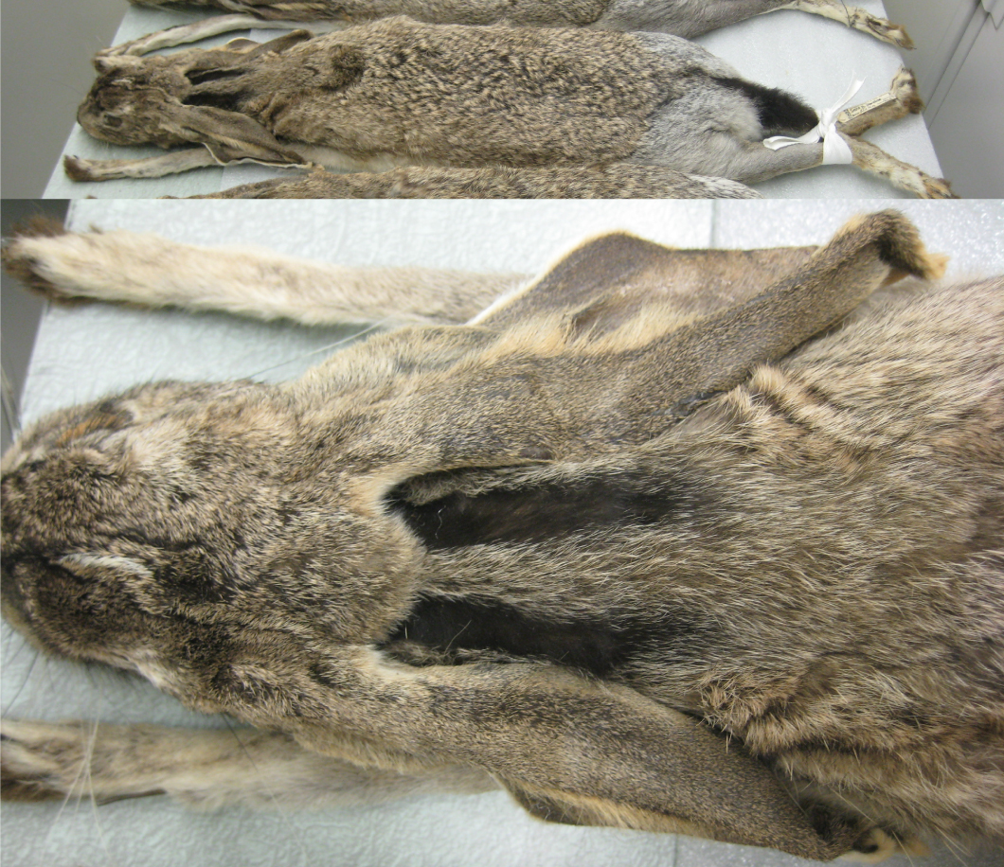

Figure 2. Distributions of L. californicus merriami and L. altamirae according to Nelson (1909). The collection sites of L. californicus curti (Hall, 1951a), L. altamirae (Nelson, 1909) and L. californicus altamirae (Alvarez, 1963) are indicated.

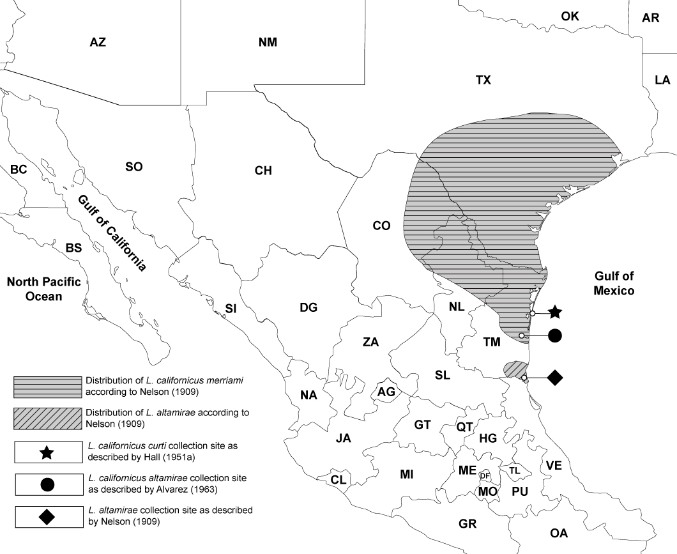

Figure 3. Phylogeny reconstructed by Bayesian and ML based on mtDNA cytb sequences using MrBayes and RAxML respectively, and GTR + G + I as the optimal substitution model. Posterior probability values are on top of branches and bootstrap support are given below branches. Note the location of USNM 93692 and 93694 as belonging to the white-sided clade with L. flavigularis.

Figure 4. Possible photo of a white-sided jackrabbit by the Comisión Nacional de Áreas Naturales Protegidas (CONANP) camera on its Área de Protección de Flora y Fauna Laguna Madre y Delta del Río Bravo in Tamaulipas as shown on “Facebook” and “Twitter” in 2016. Note the white flanks and lack of black on ear tips.

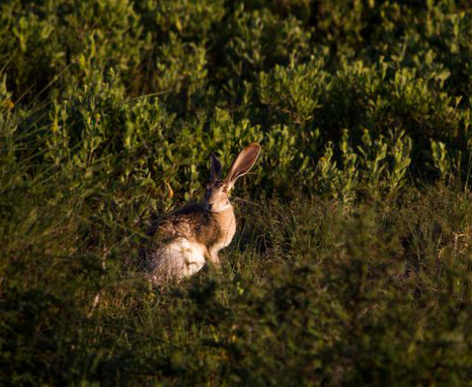

Figure 5. Possible photo of a white-sided jackrabbit from Soto la Marina, Tamaulipas, Mexico, posted on the iNaturalist website on December 14, 2014. Note the white flanks, black lines on nape and small area of black on ear tips.

