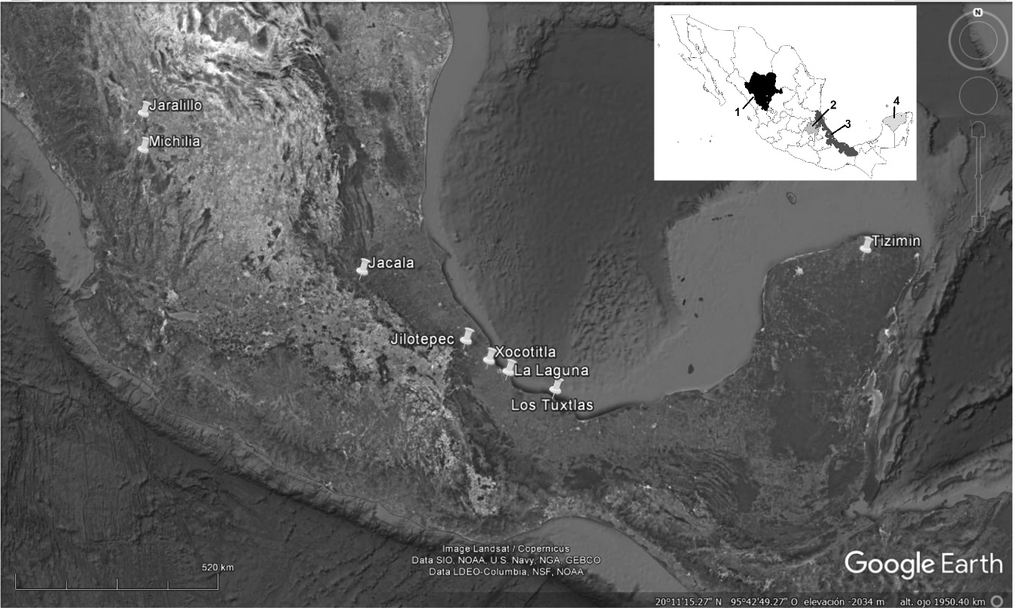

Figure 1. Location of the areas in which the processes of dung degradation by dung beetles have been studied, in the states of 1) Durango, 2) Hidalgo, 3) Veracruz and 4) Yucatán (see details in Table 1). The map was produced based on satellite imagery from the 13th of December 2015 of Google Earth V7.1.2.2041 (consulted 12th of July 2017).

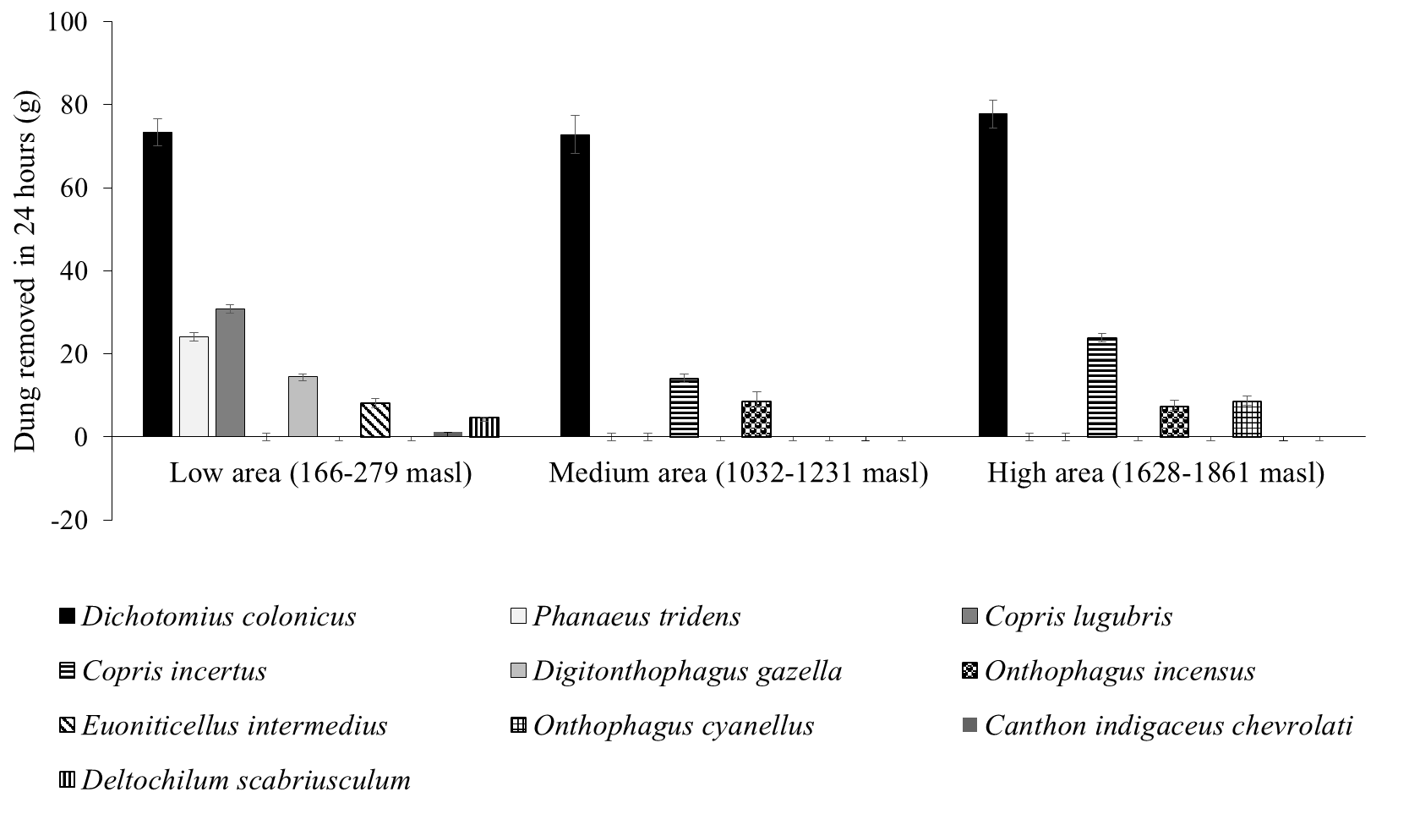
Figure 2. Average weight (± SE) in grams of dung buried in 24 hours by diverse species in 3 areas of different elevation in central Veracruz. Data ordered according to the size of each species in each area.

