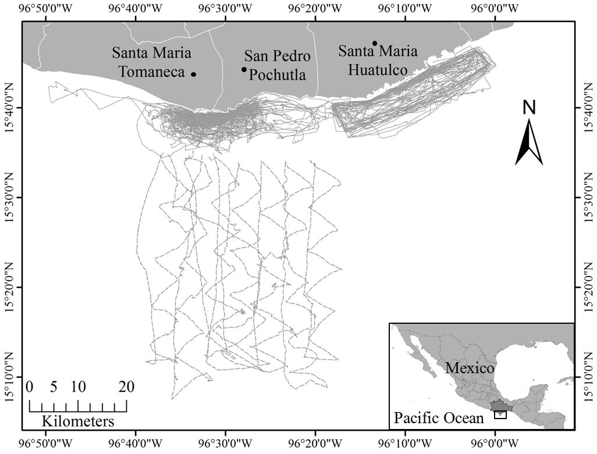
Figure 1.- Surveys carried out between December 2011 and April 2015. Continuous lines represent the coastal surveys and doted lines represent the oceanic surveys.
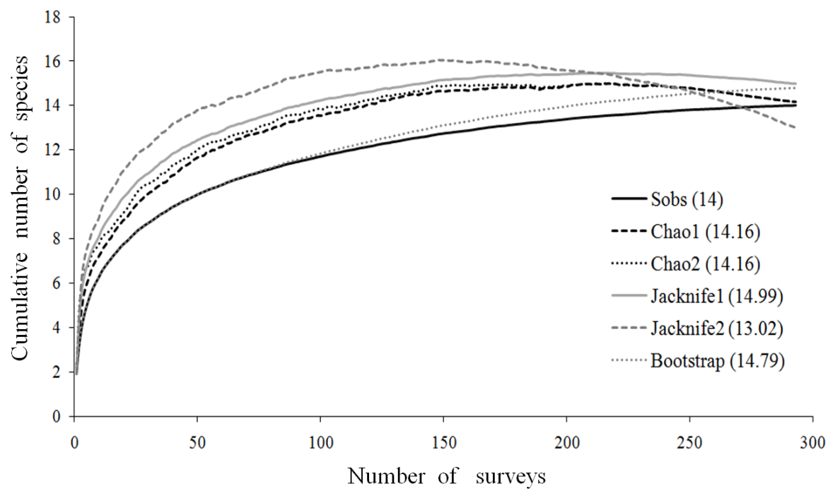
Figure 2.-Accumulation curves for marine mammal species off the coast of Oaxaca. The number of species calculated by each model appears in parenthesis.

